

***C# BASICS***

**Training Assignments**

|  |  |
| --- | --- |
| Document Code | 25e-BM/HR/HDCV/FSOFT |
| Version | 1.1 |
| Effective Date | 20/11/2012 |

**Hanoi, 06/2019**

RECORD OF CHANGES

|  |  |  |  |  |  |
| --- | --- | --- | --- | --- | --- |
| No | Effective Date | Change Description | Reason | Reviewer | Approver |
|  | 01/Oct/2018 | Create new | Draft |  |  |
|  | 01/Jun/2019 | Update template | Fsoft template | DieuNT1 |  |
|  |  |  |  |  |  |
|  |  |  |  |  |  |
|  |  |  |  |  |  |
|  |  |  |  |  |  |
|  |  |  |  |  |  |
|  |  |  |  |  |  |
|  |  |  |  |  |  |
|  |  |  |  |  |  |

Contents

Day 1: Assignment 1: Getting Start 4

Objectives: 4

Screen Requirements: 4

Functional Requirements: 4

Write your notes: 4

|  |  |
| --- | --- |
|  | **CODE: Net.S.A001**  **TYPE: SHORT**  **LOC: 100**  **DURATION: 30 MINUTES** |

# Day 1: Assignment 1: Getting Start

**Objectives:**

* Know how to create a new project named **GettingStart** in Visual Studio**.**
* Allow user enter his/her name.
* Say hello.

**Screen Requirements:**

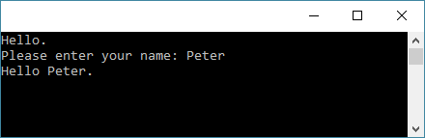

**Functional Requirements:**

* Display a message in console window.
* Read inputted data from console window.

**Write your notes:**

|  |  |
| --- | --- |
| * How do you read inputted data from console window? |  |
| * What is difference when you use Console.Read vs Console.ReadKey vs Console.ReadLine? |  |
| * How do you concatenate two or more strings in C#? |  |
|  |  |